We still have room at the table.....if you can join us.
Posted by Carl Soares
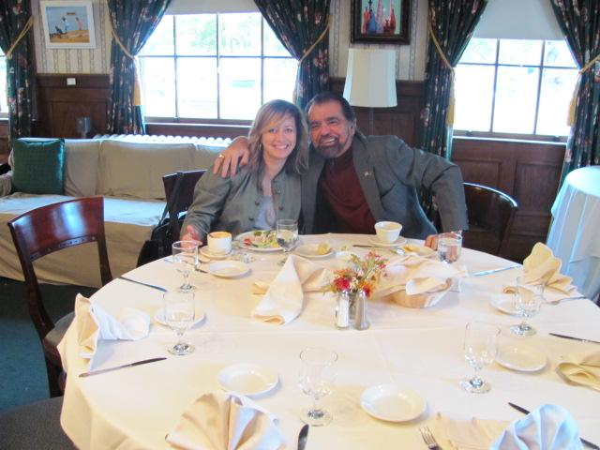
Guests JoAnne and Bernadette
Posted by Carl Soares
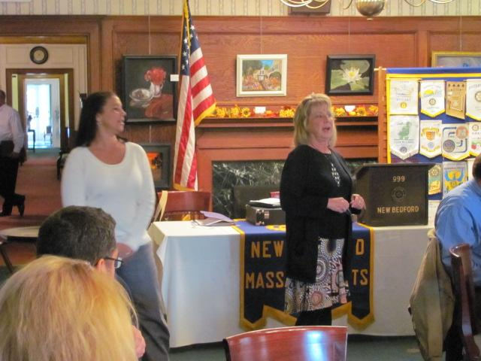
More...
Rotary Club of New Bedford
Posted by William Raus on Feb 12, 2011

The Rotary Club of New Bedford, Massachusetts is comprised of local business and community professionals who care about our city and strive to make a difference. The club’s main objective is to serve the greater New Bedford community. This is done by participating in local service projects, and by raising money that we donate to those in need.

The Rotary Club of New Bedford is one of more than 33,000 Rotary International Clubs in over 200 countries, serving the community of greater New Bedford and the world at large. The club’s core guiding philosophy is “Service Above Self.”
We invite you to take a look through our website and learn more about the history of our local club, attend a Rotary meeting as our guest, receive our weekly newsletter (the GAM), and much more!

Yours in Rotary,

Kathy Castro, President
Rotary Club of New Bedford, Massachusetts

